* 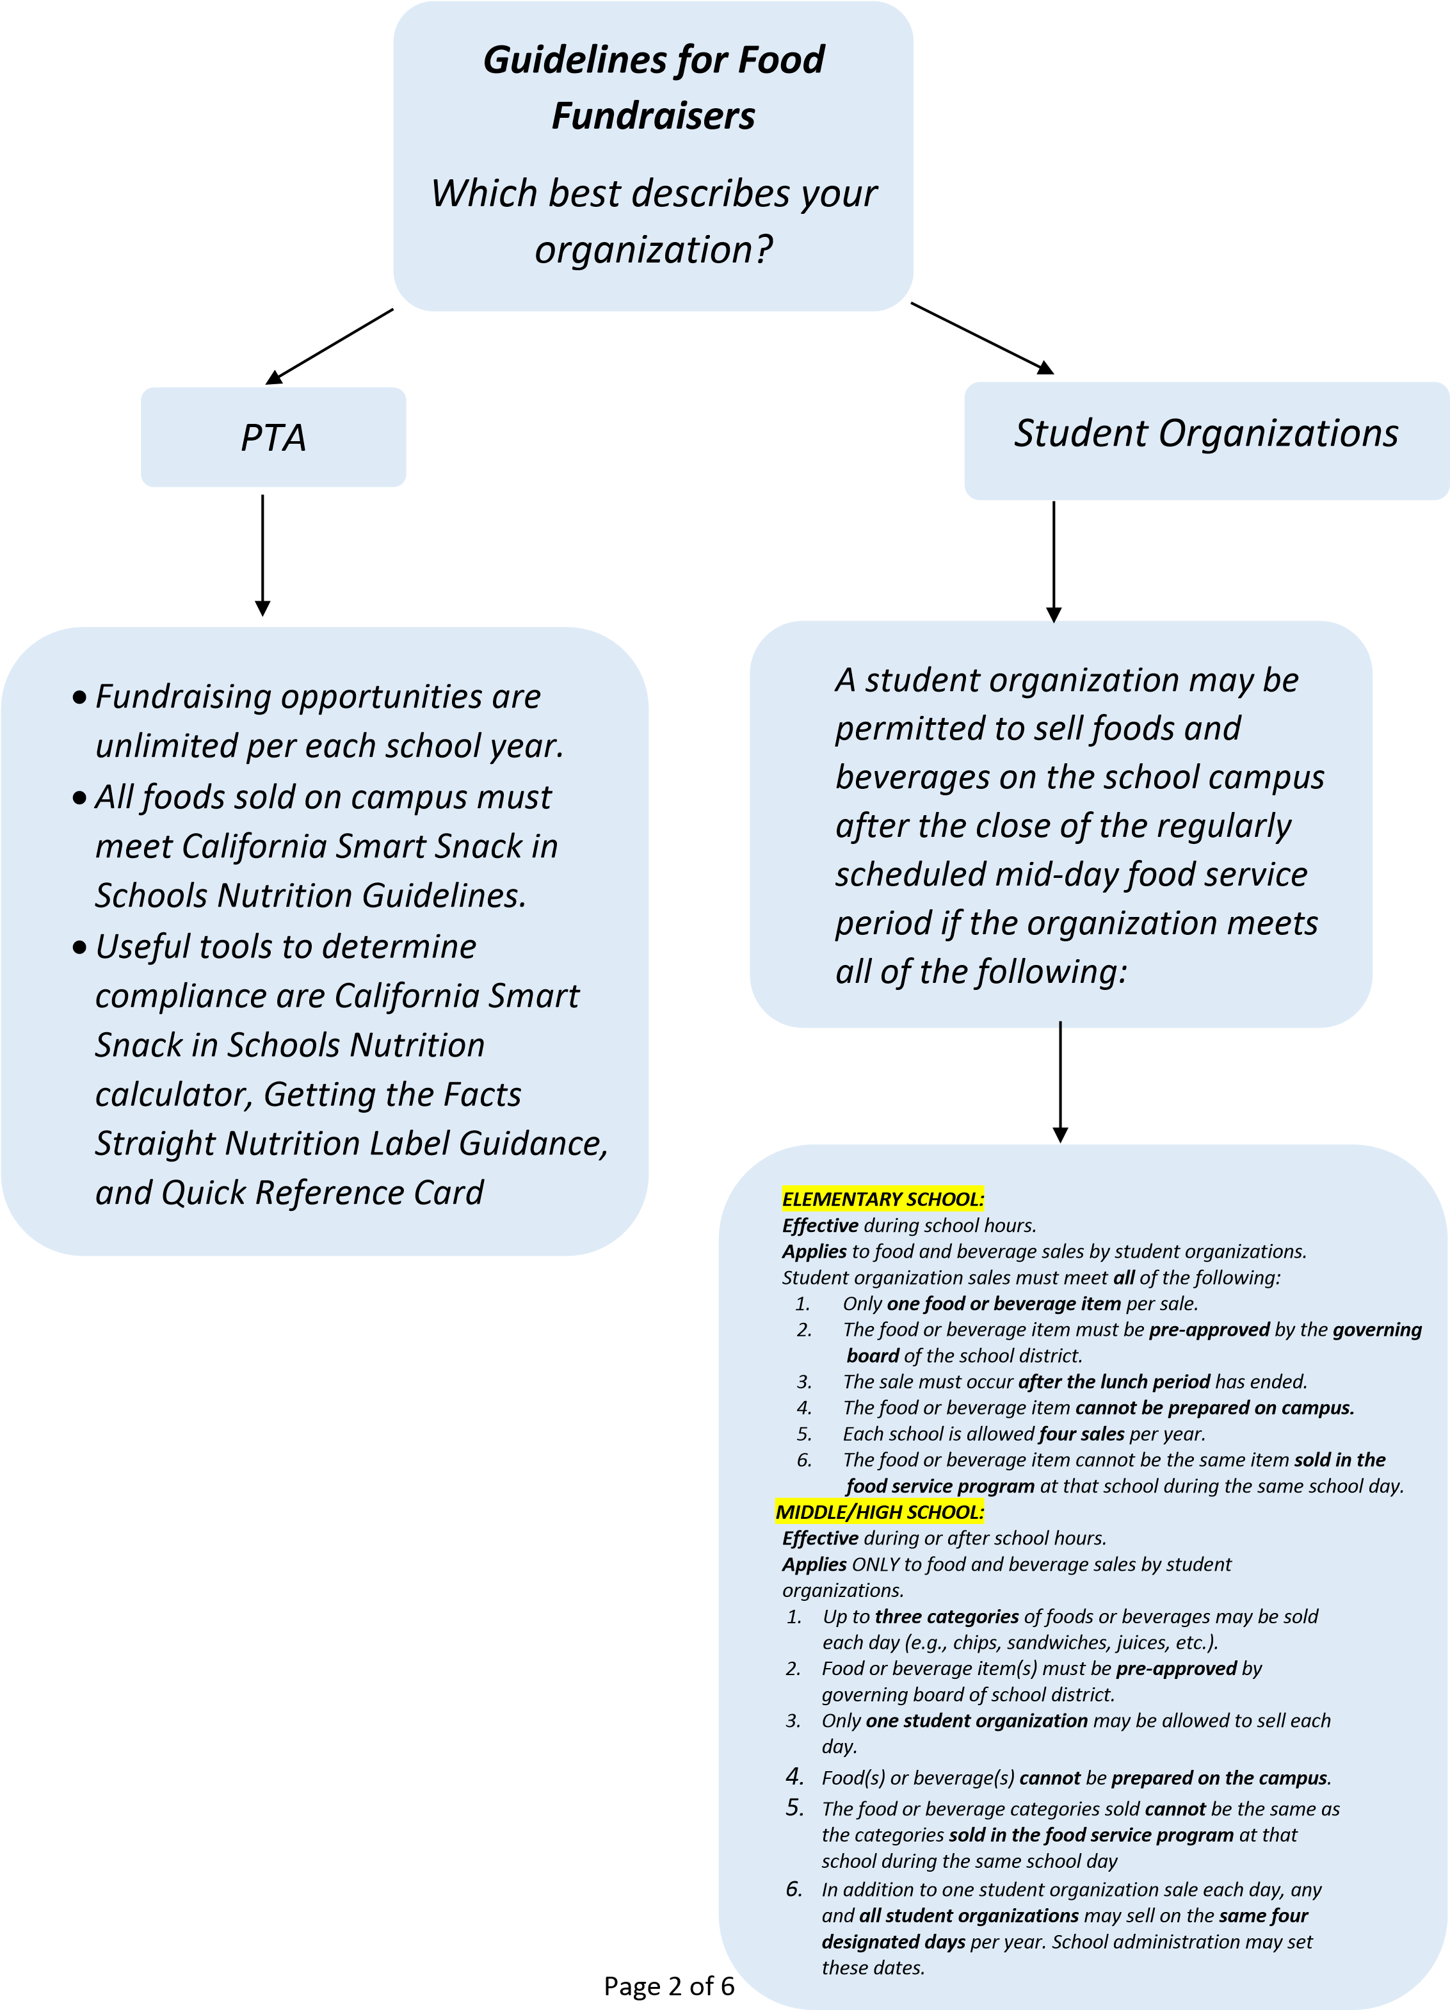

Getting the **Facts** Straight

Elementary Schools

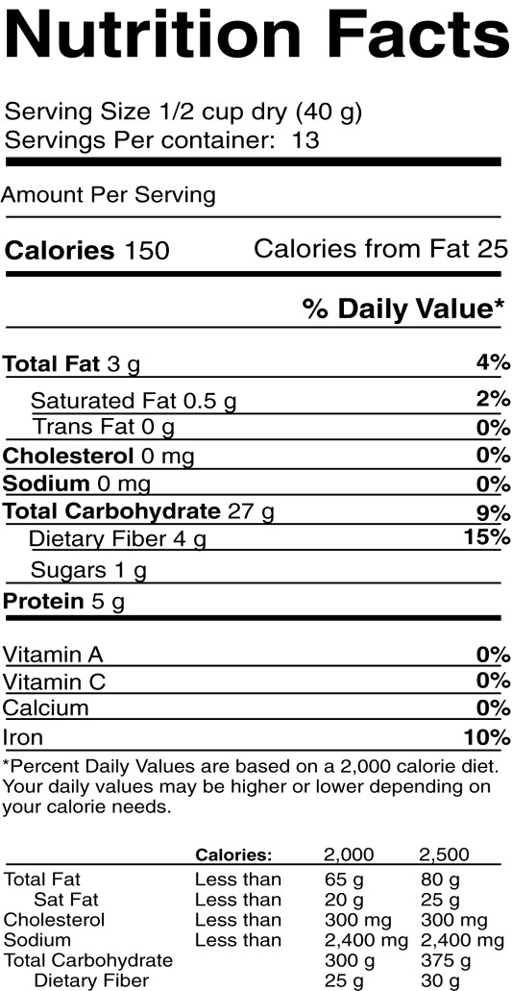

**Calories**

Check here to be sure

the calories are within

the appropriate limits:

≤

**175**

calories

per

food

Item. <200 calories for Charter School snack.



**Calories from Fat**

No more than

**35**

**%**

of

calories should be from fat.

So how do we figure this

out? The equation goes like

this: calories from fat/total

calories

= 0.17

÷ 150

25

To form a percent, we

multiply this number by 100

17

0.17

× 100 =

This means that 17% of the

calories are from fat.



**Saturated Fat**

Less than

**%**

**10**

of total calories

should come from saturated fat, but

the label lists saturated fat in grams.

A simple trick for converting grams

to calories is to remember that 1

gram of fat contains 9 calories.

Grams

saturated fat × calories per

gram = calories from saturated fat.

0.5

× 9 = 4.5 calories

But now we need to know if that is

:

10

% or less of the total calories

(

Calories from saturated fat÷ total

calories) × 100 = % calories from

saturated fat.

×

1

(4.5/150)

= 3% calories from

00

saturated fat.



**Sodium**

The sodium should be

≤

**200**

mg.



**Sugars**

Item should be no more than

**%**

**35**

sugar by weight.

(

Grams of sugar ÷ grams per

serving) × 100 = % sugar by

weight.

(1

÷40) × 100 = 2.5% sugar by

weight.



**Trans Fat**

All food items should have no

more than

**0.5**

grams

of trans fat

per serving.



*What about Whole Grains?*

Check that meals and snacks are whole grain by scanning the ingredient list. The first

item should be some type of

**whole grain**

, such as whole wheat flour.

Gettingthe**Facts**Straight

Middle Schools and High Schools



**Calories**

Check here to be sure the

calories are within the

appropriate limits:

≤

**35**

**0**

calories if the food is meant for

an

**entrée**

,

≤

**200**

calories if it is

meant for a

**snack**

.



**Calories from Fat**

No more than

**%**

**35**

of calories

should be from fat. So how do

we figure this out? The

equation goes like this:

calories from fat/total

calories

25

÷ 150

= 0.17

To form a percent, we

multiply this number by 100

× 100 =

17

0.17

This means that 17% of the

calori

es are from fat.



**Saturated Fat**

Less than

**10**

**%**

of total calories

should come from saturated fat, but

the label lists saturated fat in grams.

A simple trick for converting grams

to calories is to remember that 1

gram of fat contains 9 calories.

Grams saturated fat × calories per

gram = calories from s

aturated fat.

× 9 = 4.5 calories

0.5

But now we need to know if that is

:

% or less of the total calories

10

Calories from saturated fat÷ total

(

calories) × 100 = % calories from

saturated fat.

(4.5/150)

× 100 = 3% calories from

saturated fat.



**Sodium**

For

**entrees**

, the sodium should

be

≤

**480**

mg

and for

**snacks**

it

should be

≤

**20**

**0**

mg.



**Sugars**

Item should be no more than

**35**

**%**

sugar by wei

ght.

(

Grams of sugar ÷ grams per

serving) × 100 = % sugar by

weight.

(1

÷40) × 100 = 2.5% sugar by

weight.



**Trans Fat**

All food items should have no

more than

**0.5**

grams

of trans fat

per serving.



*What about Whole Grains?*

Check that meals and snacks are whole grain by scanning the ingredient list. The first

item should be some type of

**whole grain**

, such as whole wheat flour.