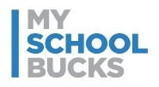***Welcome NUTRIKIDS Point of Sale***



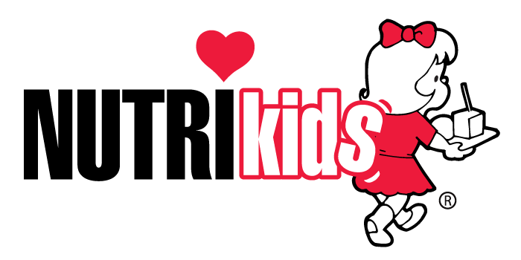

***& MySchoolBucks Online Meal Payments***

**San Angelo ISD is excited to announce MySchoolBucks – Launching on April 8, 2015.**

**What is MySchoolBucks?**  
MySchoolBucks is an online payment service that provides parents the ability to securely pay for meals, monitor student cafeteria purchases, and receive email notifications for low account balances. You can view recent purchases, check balances, and set-up low balance alerts for **FREE!**

**MySchoolBucks** will be replacing the online services for managing cafeteria accounts that are currently provided by MyPaymentsPlus. The last day of online services through MyPaymentsPlus will be on March 31, 2015. We strongly encourage current users of the online payment services to plan ahead to insure sufficient funds are available for your student during the transition between online service providers.

**Why is SAISD changing online providers?**

SAISD school cafeterias are changing their point of sale computer systems to NutriKids during the week of April 6-9, 2015 to increase the level of service and provide accurate school meal accounts. The NutriKids point of sale software will be used to track student and staff cafeteria accounts balances, student meal benefits, and daily meal counts. NutriKids system contracts with MySchoolBucks to provide online services for parents to make payments and monitor their student’s cafeteria account.

**How do I Enroll?** ***Registration for MySchoolBucks is easy and sign up begins on April 8, 2015***

1. Go to [www.myschoolbucks.com](https://www.myschoolbucks.com/) and register for a free account.
2. Activate your account and add students. You will need your student's name and school ID number.
3. Make a payment to your students’ accounts with your credit or debit card.

*A program fee will apply. You will have the opportunity to review any fees and cancel if you choose, before you are charged. Reminder: Electronic checks are not accepted by San Angelo ISD at this time.*

If you have any further questions, please visit www.myschoolbucks.com and select the Help/FAQ link. If you need assistance with the enrollment process, please call MySchoolBucks Customer Support at 1-855-832-5226.

**Additional Information Parents Need To Know About The Upcoming Changes:**

**Simplified Account Balance** – In the new NutriKids POS system a single or one balance amount is maintained for each student cafeteria account. Funds deposited into the student account can be used for school meals and general item purchases in the cafeteria. General item purchases include all items sold a la carte in the cafeteria such as ice cream, snacks, beverages, and extra menu item servings.

*Reminder: Students are not allowed to charge any general items per District policy. For more information about the District’s charge policy visit* [*www.saisdschoolnutrition.com*](http://www.saisdschoolnutrition.com) *under the prepayment options tab.*

**Cafeteria Account Balances -** All cafeteria account balances in the previous POS system will be transferred to the new system automatically. Balances in the Meal and General Account will be consolidated into one balance.

**Simplified Convenience Fee (*applies only for on-line payment transactions*)** MySchoolBucks charges a set rate of $1.95 each time a payment is made online with a credit or debit card regardless of the amount of purchase. Parents can apply money to multiple student accounts, even at different campus locations within the district, with one single credit or debit card online payment transaction.

*Helpful Hint: Using the practice of applying funds to multiple accounts at the same time or making larger deposits into the accounts in one online payment transaction will save parents time and money.* **Cash and check payments will still be accepted at all school cafeterias.**

Thank you for your understanding during this conversion of services.

SAISD Food and Nutrition Services Department