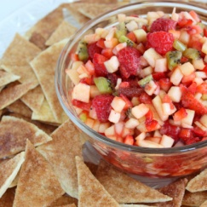
Fruit Salsa

1 large apple, cored and diced
½ cup strawberries, diced
½ cup mango, diced
2 Tbsp. applesauce
1 Tbsp. lime juice
2 Tbsp. sugar or honey
½ tsp. ground cinnamon

Gently mix ingredients. Cover and chill in the refrigerator approximately 20 minutes.

Serve with cinnamon pita chips or graham crackers or on top of pancakes.

Try other fruits in this recipe such as kiwi, pineapple, bananas or oranges.
Yield: about 2 cups
Compliments of Prince William County School Food & Nutrition Services

