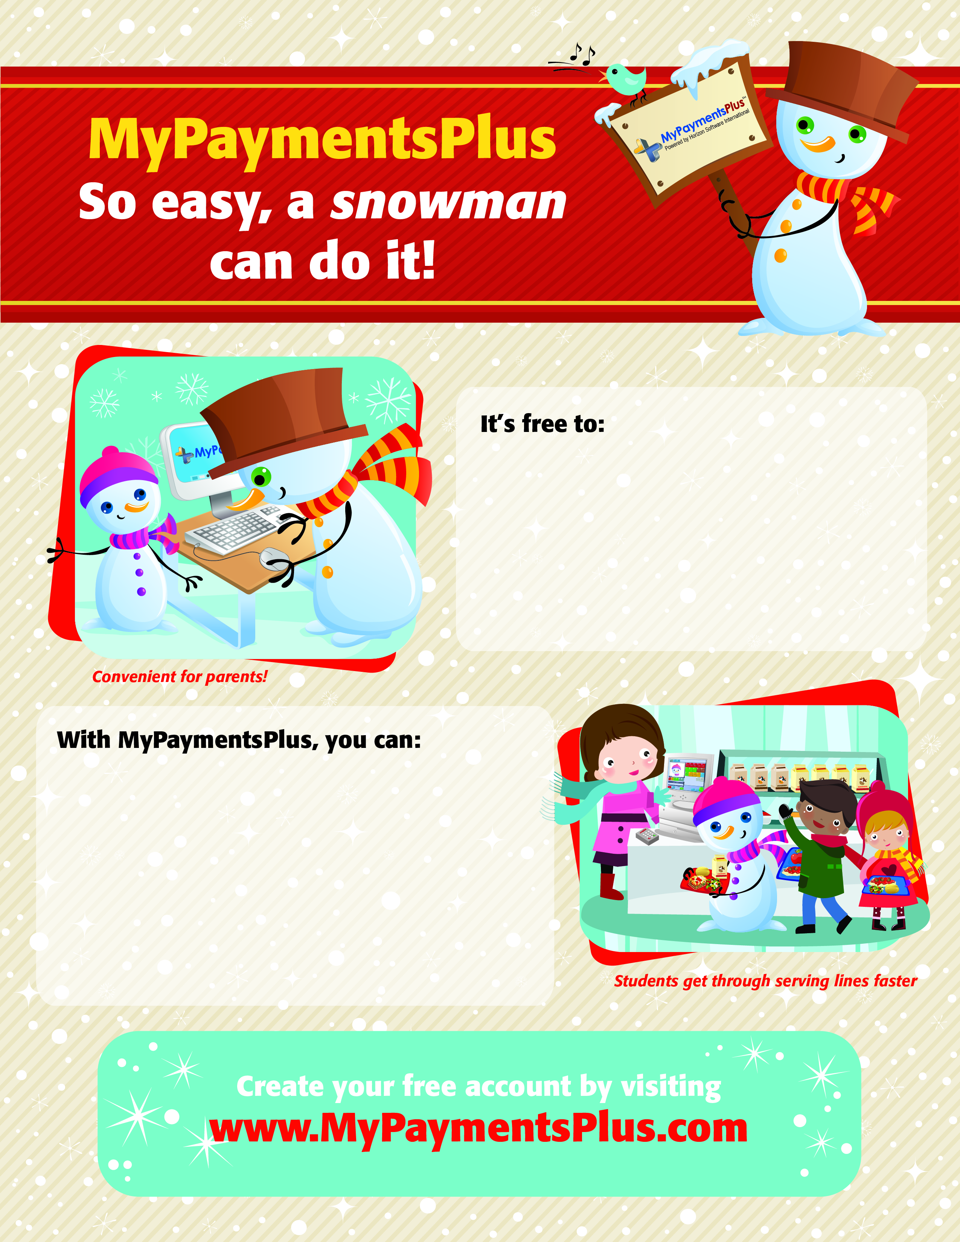

* Sign up for the program
* Monitor student purchases
* View student account balance 24/7
* Receive notifications when your student’s balance is low
* Make payments to your student’s lunch account using a credit or debit card
* Check account balances free anytime at [**www.MyPaymentsPlus.com**](http://www.MyPaymentsPlus.com)
* Set up recurring payments