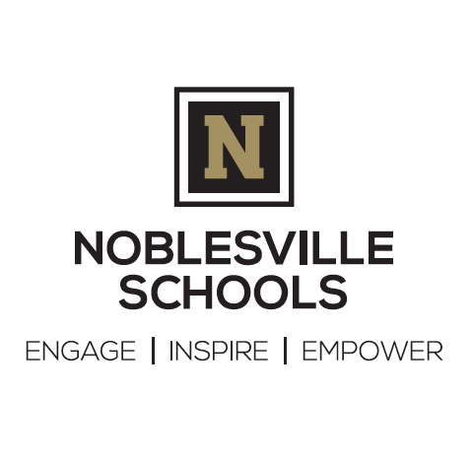
Request for Refund or Transfer of Cafeteria Funds
Student Information:

Name________________________________________________________________________________

School Attending ______________________________________________________________________

Reason for refund (circle one)

Left School District Graduated Other (specify)________________________________________

Please indicate how you would like to disburse the balance of your student(s) lunch account:

CHECK (will be mailed)

Requested by:___________________________ Relationship to Student:________________________

Telephone:_____________________________ Date of Request______________________________

Address:________________________________ City:__________________ State:___ Zip:__________

Transfer to student(s) within Noblesville Schools

1. Name____________________________School___________Grade_____Amount_______

2. Name____________________________School___________Grade_____Amount_______

Donation

Please donate the balance of my student’s account to the Lunch Donation Fund
These funds will be used to support students in need

SIGNATURE________________________________________________ Date_____________________
=====================================================================================
Please submit form to:
Cindy_evans@nobl.k12.in.us

Refunds may take up to four weeks to process. Checks will be mailed to the name and address listed above. Transfer of funds to other students will be processed within a week from receipt of form.

Funds remaining in students' lunch accounts at the end of each school year will automatically be applied to the student's balance for the next school year. Only in the event that a student leaves the district (i.e. moves, graduates, etc) may a refund of account balance be requested via this form.

Questions? Contact the Food Service Department at 317-773-3171

This institution is an equal opportunity provider.

