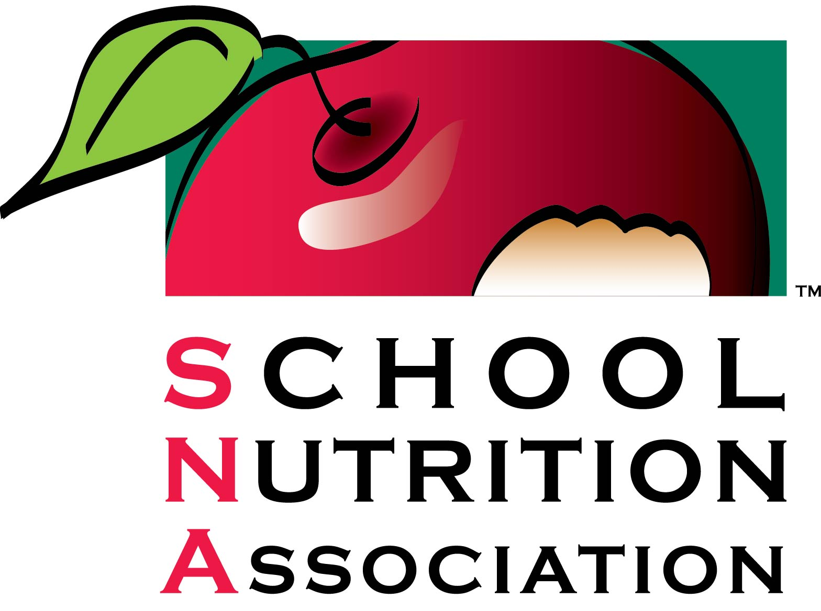

Boise School District Food Service Manager Wins National Recognition

(National Harbor, MD – May 2, 2017) – The national, non-profit School Nutrition Association (SNA) has awarded Kathy Carpenter from Morley Nelson Elementary in Boise School District, ID, the Northwest regional Manager of the Year Award, considered the highest honor a school nutrition manager can earn. The award recognizes a cafeteria manager who has demonstrated dedication and ingenuity to improve his or her school meal program.

As food service manager, Kathy Carpenter started an at-risk supper program last year for children and adults and works tirelessly to organize and train involved staff. She and her staff continue to serve as many students as they can which helps with the promotion of meals to those in need. Carpenter knows how to utilize her expertise in the school setting and always uses school open houses as an opportunity to educate parents and guardians about the School Nutrition Program. She volunteers at the annual Morley Nelson track and field event to emphasis the importance of physical activity. She makes a difference in the Greater Boise community as well, volunteering at the food bank for the “backpack program,” helping sort donated product and assisting the local chapter to make blankets and help-baskets for local charities.

“Cafeteria managers serve as leaders to their employees and utilize creative and exciting ways that improve the health and well-being of their students,” said SNA CEO Patricia Montague, CAE. “Kathy Carpenter goes above and beyond to better her students’ experience, while continuing to reach out to the larger community at Morley Nelson Elementary.”

The Manager of the Year Award is given in honor of Louise Sublette, a leader in school nutrition in her state and in the national School Nutrition Association. During her 43 years in the profession, Sublette worked in many areas of foodservice—public schools, colleges, hospitals and elderly feeding programs. Sublette dedicated her career to honoring school nutrition professionals and ensuring those who work in school cafeterias have access to professional development opportunities, empowering them to help their school meal programs flourish.

In July, Carpenter will be honored during the Awards Ceremony at the School Nutrition Association’s Annual National Conference in Atlanta, GA.

About School Nutrition Association:
The School Nutrition Association (SNA) is a national, non-profit professional organization representing 57,000 school nutrition professionals across the country. Founded in 1946, SNA and its members are dedicated to making healthy school meals and nutrition education available to all students. For more information on school meals, visit www.SchoolNutrition.org/SchoolMeals.

