Fridley School District
6000 West Moore Lake Drive
Fridley, Minnesota 55432
Phone: 763-502-5000

FEEPAY INSTRUCTIONS
Instructions for setting up your student’s TIES FeePay account:
Please use a browser other than Internet Explorer such as Firefox or Chrome. Website: https://fridley.feepay.com/

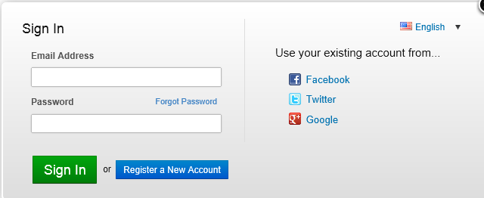

- Register a new account using existing Facebook, Twitter, or Google account.
- Or register a new account by using your email address.

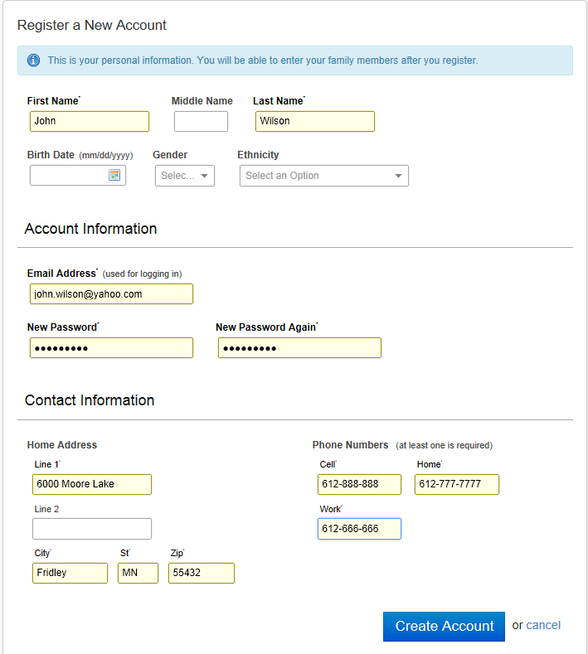

To add your students use the “Add Family Member” button:

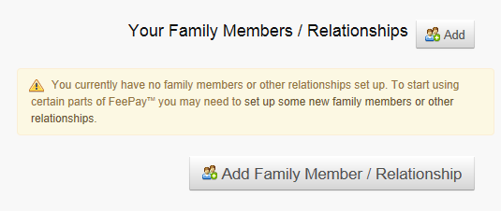

When setting up your student you must select: “Yes, They Have A Student Id”

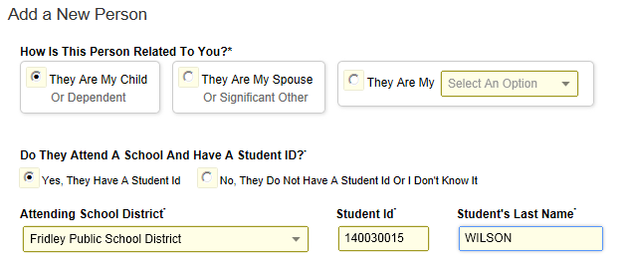

Your student’s ID number or student # is located at the top of your student’s schedule

13-14  Fridley High School  6000 West Moore Lake Drive, Fridley MN 55432  Generated on 08/12/2013 02:08:17 PM | Student Schedule for Wilson, John M  Grade: 12 Student Number: 00140030015 **  Courses enrolled: 19  Mailing Address: 6200 Riverview NE, Fridley, MN 55432

** Important if the student number has leading zeros do not enter the leading zeros.
(Example 00140030015 should be entered 140030015).

SET UP AN ALERT FOR EACH STUDENT IN YOUR FAMILY

AUTOPAY OPTION

Autopay allows you to automatically add money to your students meal account when the balance gets to the desired amount you have set up.

To set up AutoPay:
Click on ALERTS & AUTOPAY tab
Click on Add Auto Pay
Modify dollar amounts and payment option
IMPORTANT – select CREATE AUTOPAY button

To set Alert and/or AutoPay for additional family member:
Click on dropdown arrow next to student name
Select sibling’s name
Repeat above steps

