#31529 – White Whole Wheat Breadsticks

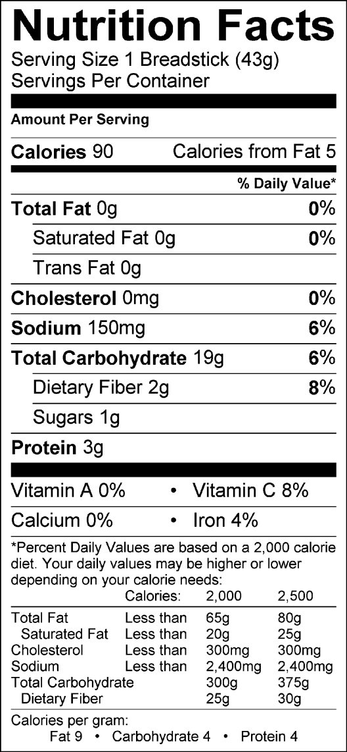
INGREDIENTS: WATER, WHOLE WHEAT FLOUR, UNBLEACHED UNBROMATED ENRICHED WHEAT FLOUR (WHEAT FLOUR, NIACIN, REDUCED IRON, THIAMINE MONONITRATE, RIBOFLAVIN, ENZYMES, FOLIC ACID), HONEY, YEAST, SALT, DOUGH CONDITIONERS (MONO & DIGLYCERIDES, DATEM, L-CYSTEINE, ASCORBIC ACID, ENZYMES), MODIFIED FOOD STARCH, FAVA BEAN FLOUR, FLAVOR (NATURAL FLAVOR, MODIFIED VEGETABLE GUM, HYDROLYZED STARCH, MALTODEXTRIN), MALTED BARLEY FLOUR, DEXTROSE, RYE FLOUR.

CONTAINS: WHEAT

