**C:\Users\JGraf\AppData\Local\Microsoft\Windows\Temporary Internet Files\Content.IE5\P84D3HW9\MC900215358[1].wmfA Nutritious Start to Every Day**

At all of our ANESU schools we provide breakfast to students because of the many benefits it provides for learning! It improves student’s performance in school and overall health. More of these benefits are highlighted below:



**Breakfast Meal Guidelines**

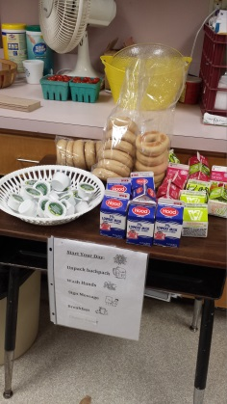The breakfast that we serve at ANESU meets the USDA guidelines for school meals. This ensures our students are receiving the nutrition they need to perform well in school. Whether it is served in the cafeteria or in the classroom, 0ur breakfasts provide one serving each of fruit, whole grains, and milk. Combining these food groups at breakfast helps students focus during the school day.

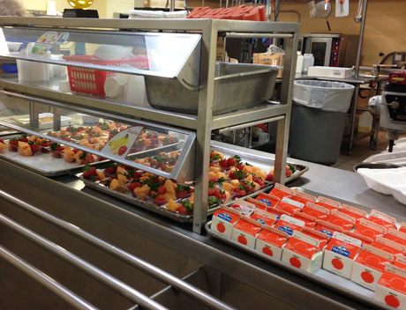



**Sample Breakfast Menu Served in the Cafeteria**

**Sample Breakfast Menu Served in the Classroom**

To view the breakfast menu at your child’s school please visit our [menu page](http://anesunutrition.com/index.php?sid=1608122012069872&page=menus)